Smart Breakout Board
  - New School Mining
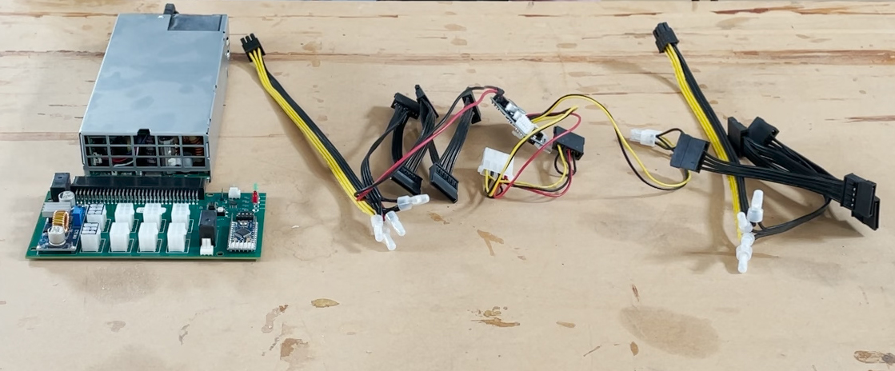
Version 1.12
TAble of
Contents
Quick Start Guide 1
Board Details 3
Components 4
Status LEDs 4
Power Button 5
PCIe GPU Power 5
Wiring Harness Connectors 5
68 Pin Dell PSU connector 5
Hackers Guide 6
Details 7
Arduino Pro Mini 7
Relay controlled switch 7
DC-DC Power Converter 7
4 Pin DIP switches 8
RS485 connector 8

Quick Start Guide
To get started with the smart breakout board follow these steps to quickly get the system up and running.
- Take you Dell Server power supply and disconnect it from AC power.
- Plug the 68-pin connector of the smart breakout board to the Dell Server PSU. The label on the PSU should be on the same side as the back of the Breakout Board.
- Plug the two wiring harnesses provided with this kit into the 6 PCI power connectors that have black color at the top of the connectors.
- Plug up-to 6 PCIe power cables into the white 6 Pin connectors. Use these to power your GPUs
- Plug SATA powered riser cards into the connectors from the wiring harnesses provided by the kit.
- Once everything is connected, plug the AC power into the Dell Server PSU
- You should see one green LED light up and one red LED flashing. This indicated that the board is in “standby”.
- Now press the small white button near the LEDs on the breakout board.
- The other green LED should also light up and the red LED should be on constant. At this point power is on.
- You will now need to press the power button connected to your motherboard (or configure the motherboard to turn on after power interruption, typically found is the motherboards BIOS)

Board Details
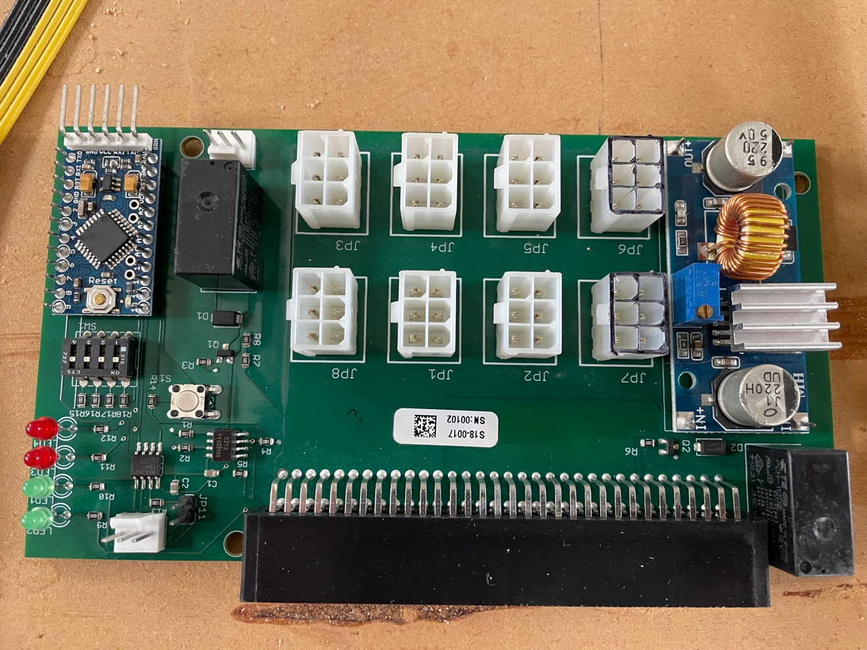This picture of the breakout board shows some of the key components of the board. Here are their descriptions:
5
4
3
2
1
- Status LEDs
- Power Button
- PCIe power for GPUs
- Power connectors for wiring harnesses
- 68 Pin connector that connects to the Dell Server PSU

Components

Status LEDs

Green LED 1
The bottom LED in the picture above, it is the LED closest to the Dell PSU and labeled LED2 on the PCB. This LED indicates the presence of 12V power from the dell power supply. This means that the Dell PSU is “On”

Green LED 2
The second LED up from the bottom in the picture above. Labeled LED1 on the PCB. This LED indicates the presence of 3.3v power from the dell power supply that powers this breakout board. When the system is in “Standby” this LED will still be lighted

Red LED 3
The thirds LED up from the bottom and labelled LED3 on the PCB. This LED is controlled by the Arduino Pro Mini and will flash when the system is in “Standby” and be on solid when the system is “On”.

Red LED 4
The top LED in the picture above and labelled LED4 on the PCB. This LED is controlled by the Arduino Pro Mini and unused in the current firmware.

Power Button
Pressing this button will toggle the state of the breakout board from “Standby” to “On”. The power state of the breakout board is persisted if power is lost, so if the board was “On” and power was lost at the Dell PSU then when power is restored to the Dell PSU the breakout board will remain in the “On” status.

PCIe GPU Power
These 6 connectors, identified by being all white, are there to power the GPUs. These connectors are standard PCIe 6 Pin Power connectors with 3 pins of 12V and 3 Pins of GND. Never connect GPUs to the connectors with black on the top. These connectors are for the wiring harnesses only.

Wiring Harness Connectors
These two connectors signified with black on the top are designed for the wiring harnesses. They provide both 12V and 5V power to the harness for optimal powering of SATA riser cards. Never connect GPUs to these connectors. Doing so will short out the breakout board PSU and possibly damage your GPU.

68 Pin Dell PSU connector
This connector is designed to connect to the Dell PSU. The bottom of the breakout board should be towards the bottom of the PSU. The bottom of the PSU typically is the side with the label on it. It’s also the side that the connector from the PSU is closest to.

Wiring Harnesses

ATX PSU Harness
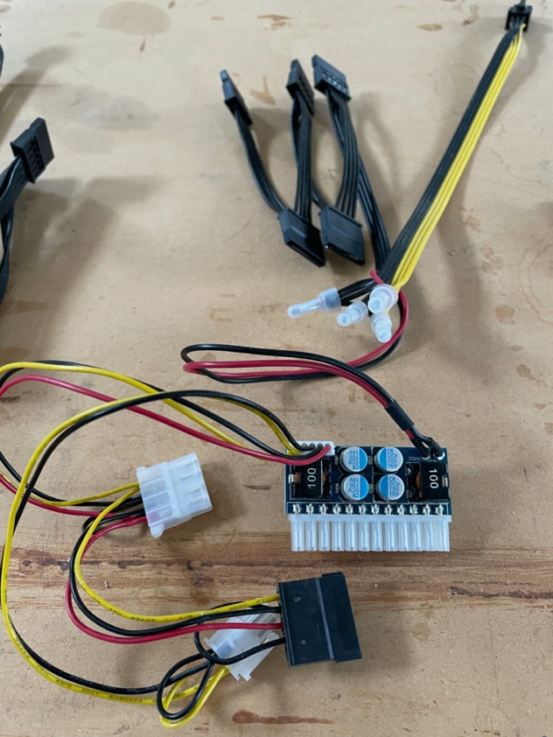
This harness is designed to power a standard ATX motherboard. The device with the white connector on the bottom will plug into the 24 pin power connector on the motherboard. There is also a 4 Pin connector that will provide the CPU power for the motherboard. If you motherboard has an 8 pin CPU power, that is ok, just plug the 4 pin connector to one side. This Pico PSU is designed for low to medium wattage CPUs, anything 100W or less should be fine. The ATX Pico PSU is rated at up to 160W total power.
In addition to the ATX power this harness provides 5 SATA power connectors, intended to power 3 SATA riser cards.

Riser Card only Harness
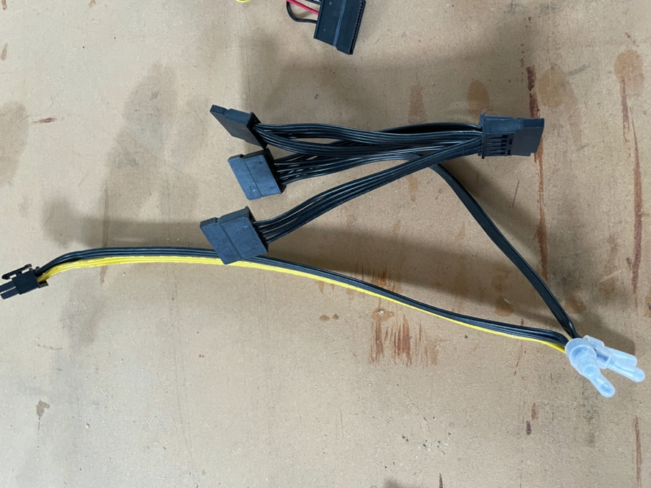
This harness is the same as other just without the Pico PSU. It has 5 SATA power connectors and is designed to power 3 SATA riser cards.

Hackers Guide
3
2
5
4
1
- Arduino Pro Mini
- Relay controlled switch
- DC to DC Power Converter
- 4 Pin DIP Switches
- RS485 Serial Interface

Details

Arduino Pro Mini
This is a standard Arduino Pro Mini, running at 8 MHz with 3.3V power. The 6 Pin header can be uses to connect a USB-to-serial adapter and then you can use a standard Arduino App to program the Arduino. There are many tutorials about using this on the Internet, just google.
Our reference firmware can be found on GitHub at
https://github.com/benpayne/PowerBreakout

Relay controlled switch
The Arduino has one relay for turning on the Dell PSU. There is a second relay that controls this header. The middle pin is common, and the left and right pins will be, closed and open when the relay is not active. When the relay is activated, they will change to open and closed respectively. So, if you want a normally closed switch connect the left and center pins. If you want a normally open switch connect to the right and center pins.

DC-DC Power Converter
This power converter is used to take 12V power and generate the 5V power that the SATA connector and riser cards need. On the riser cards this 5V power is converted to 3.3V for the PCIe slot. We default the board to 5V output, so the SATA plug provides the right power. However, you can optimize the setup by turning the voltage down so the linear voltage regulator on a SATA riser is more efficient. In this case we recommend tuning down to 4.2V. Any lower and the LVR might not be able to maintain 3.3V accurately.

4 Pin DIP switches
These pins are directly connected to the Arduino and will allow and ID to be specified for this board. This is intended to allow the board to be identified on the serial bus. RS485 allows for several devices to be daisy-chained together. Without this ID there would be no way to assign a command to a specific board.

RS485 connector
This allows for multiple board to be connected together. There is also a jumper next to this connector, when closed that will enable a termination resistor. Each end of a RS485 bus should have a termination resistor activated. This bus can also be connected to a PC or Raspberry PI (via an interface adapter). This would allow for monitoring and control from a PC or Web. This software is not supplied by NSM at this time. But checkout the firmware source code for a reference of the commands supported by the breakout board.
In addition to the command and control from the PC or Pi. Each power supply will announce a change in the power state to other devices that have the same ID (see DIP Switches). This allows PSUs to be grouped together to turn on/off together.
Connecting devices should be a “daisy-chained” together. So pin 1 to pin 1, pin 2 to pin 2, etc…. NSM provides cables for this purpose as well if you don’t want to build your own. If you do build you own pins 1 and 2 should be twisted pair. Pin 3 provides a common ground. Pin 3 is closest to the LEDs.

